Installing ldp.exe on Windows Server 2012 **without installing the AD role.**

Do the following (from here: https://social.technet.microsoft.com/Forums/en-US/a3ad47e9-f2a7-436e-9efb-f1e4a6b0ee6e/ldpexe-unable-to-create-new-document?forum=winserverDS):  
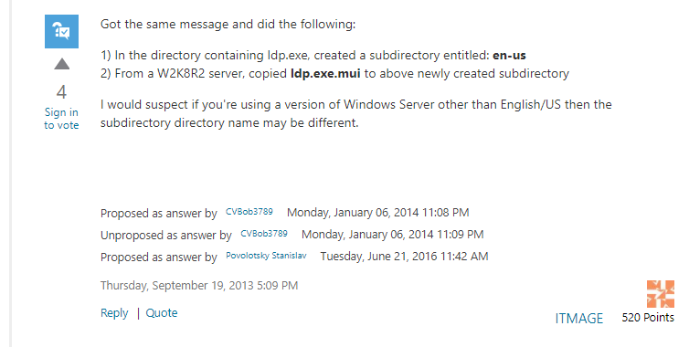  
  
From my Wk2012 AD server, I copied the following 64-bit files:  
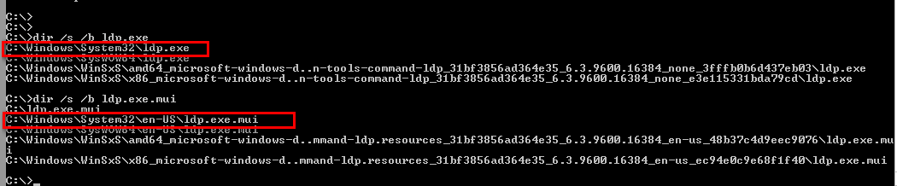  
  
As per the steps, I then copied these to my CW appliance and created a “en-US” directory:  
  
With ldp.exe.mui in the “en-US” directory:  
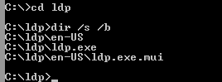  
  
Double-click ldp.exe and it should launch successfully:  
  
  
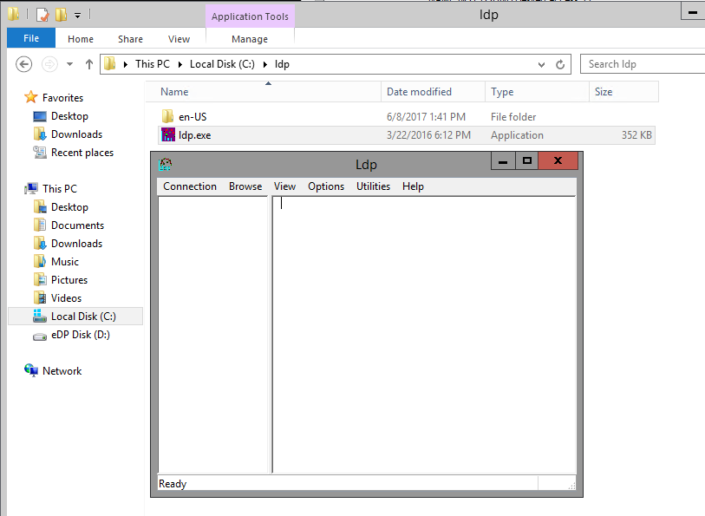

I can confirm that this ldp.exe does seem to work successfully without any issues:  
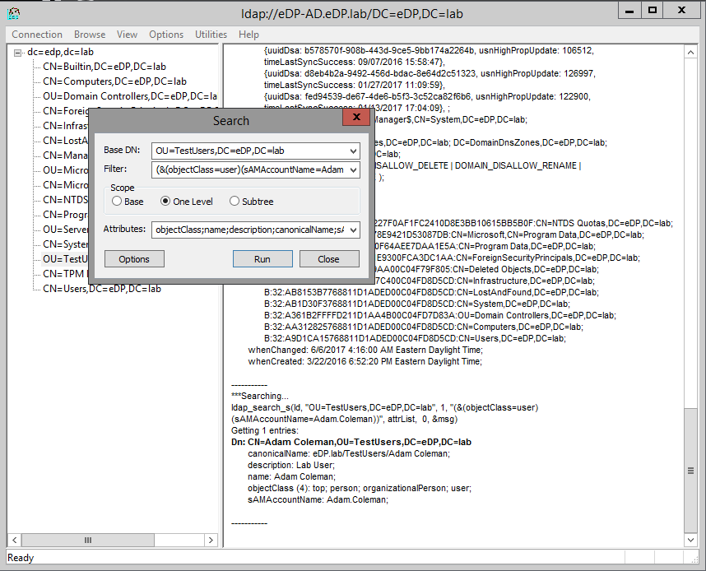

*JeremyC 08-06-2017***END**